Initial Commit

1. recruit@umuzi:~$ mkdir git-basic-exercises

2. recruit@umuzi:~$ cd git-basic-exercises
recruit@umuzi:~/git-basic-exercises$

3. recruit@umuzi:~/git-basic-exercises$ ls -a
. ..

4. recruit@umuzi:~/git-basic-exercises$ git init
Initialized empty Git repository in /home/recruit/git-basic-exercises/.git/
recruit@umuzi:~/git-basic-exercises$ ls -a
. .. .git

5. recruit@umuzi:~/git-basic-exercises$ git status
On branch master

No commits yet

6. recruit@umuzi:~/git-basic-exercises$ touch README.md
recruit@umuzi:~/git-basic-exercises$ ls -a
. .. .git README.md
recruit@umuzi:~/git-basic-exercises$ git status
On branch master

No commits yet

Untracked files:
(use "git add <file>..." to include in what will be committed)

README.md

nothing added to commit but untracked files present (use "git add" to track)

7. recruit@umuzi:~/git-basic-exercises$ git log
fatal: your current branch 'master' does not have any commits yet

8. recruit@umuzi:~/git-basic-exercises$ git add README.md

9. recruit@umuzi:~/git-basic-exercises$ git status
On branch master

No commits yet

Changes to be committed:
(use "git rm --cached <file>..." to unstage)

new file: README.md

10. recruit@umuzi:~/git-basic-exercises$ git rm --cached README.md
rm 'README.md'
recruit@umuzi:~/git-basic-exercises$ git status

11. recruit@umuzi:~/git-basic-exercises$ git commit -m "initial commit"
[master (root-commit) 58b77a5] initial commit

12. recruit@umuzi:~/git-basic-exercises$ git log
commit 58b77a5474fd2bee0bed9865f0bbe39825235ee8 (HEAD -> master)
Author: Boitumelo-Msiza <boitumelomsiza20@gmail.com>
Date: Fri Jan 17 09:59:55 2020 +0200

initial commit

More Commits

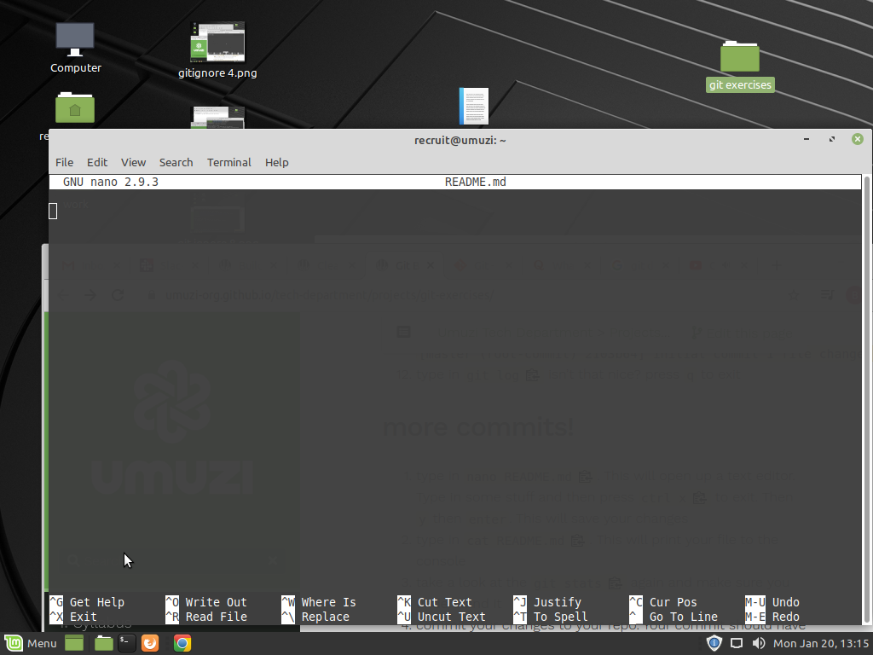
1

2. recruit@umuzi:~/git-basic-exercises$ cat README.md
life is beautiful

3. recruit@umuzi:~/git-basic-exercises$ git status
On branch master
Changes not staged for commit:

4. recruit@umuzi:~/git-basic-exercises$ git commit -m "second commit"
[master 35330fc] second commit
1 file changed, 1 insertion(+)

5. recruit@umuzi:~/git-basic-exercises$ git commit -m "Third commit"
[master fa96519] Third commit
1 file changed, 5 insertions(+)

Check this out

1

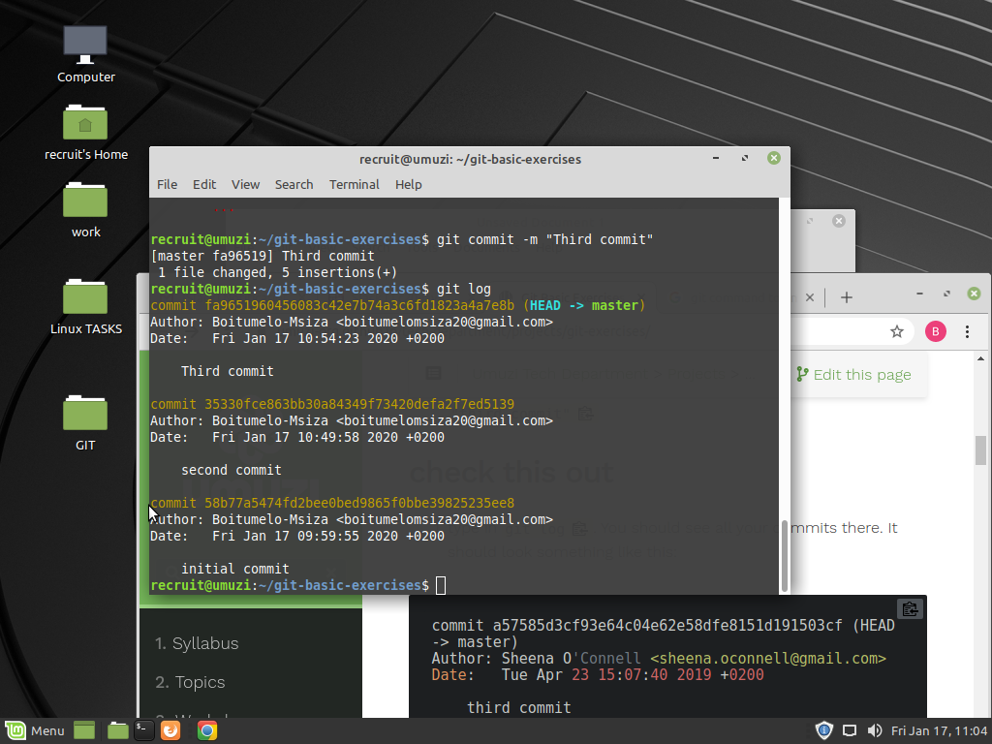

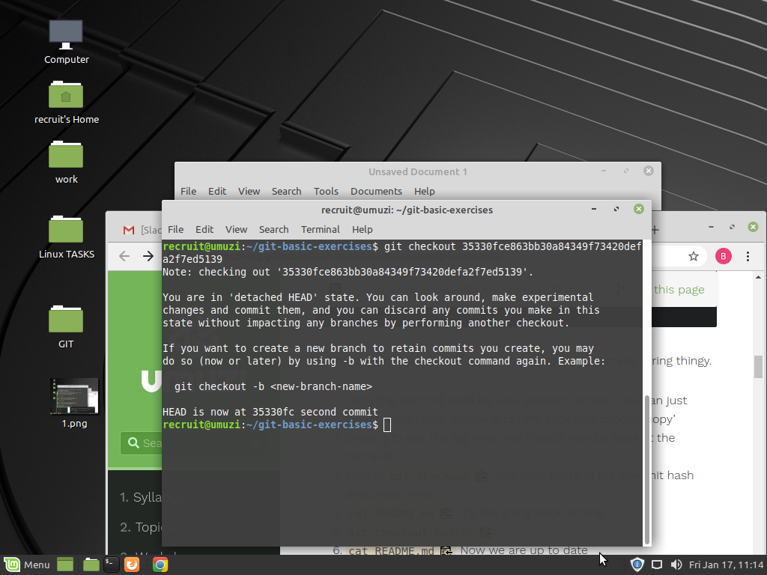
3

4
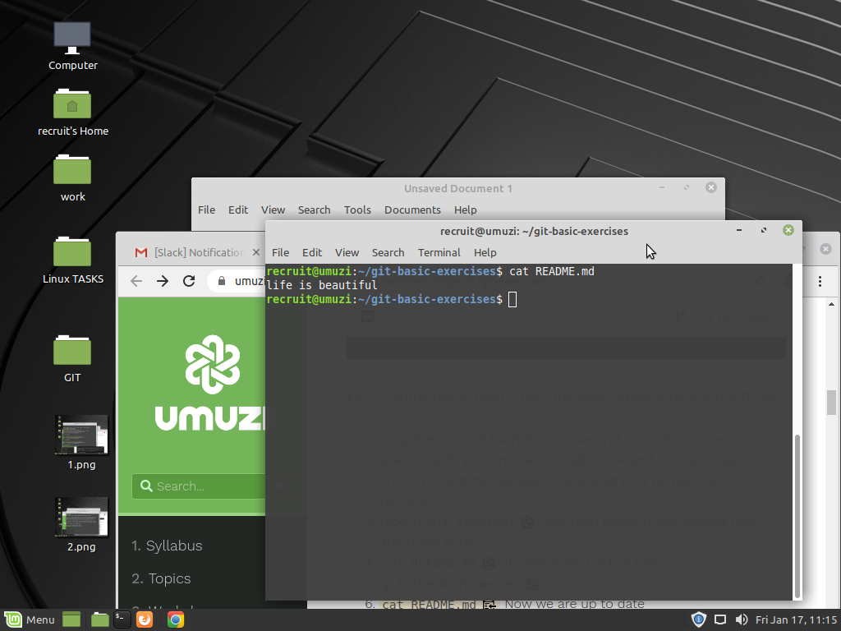

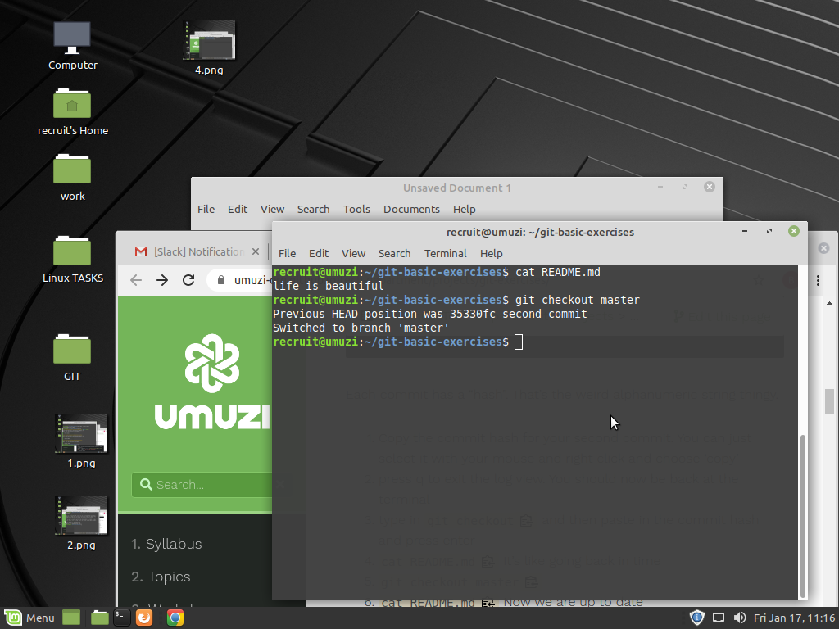
5

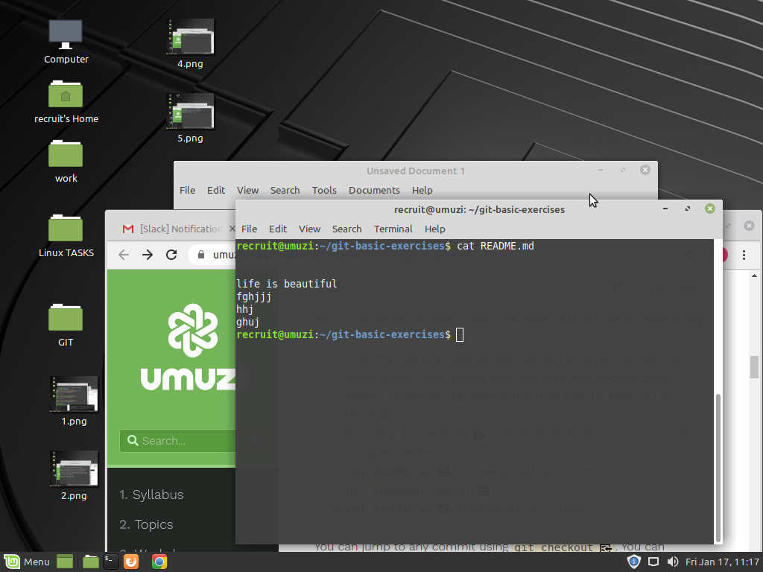
6

Branching

1. recruit@umuzi:~/git-basic-exercises$ git branch
* master
shows all the branches of which in this case its the default master branch

2. recruit@umuzi:~/git-basic-exercises$ git branch milkshake-flavours

3. recruit@umuzi:~/git-basic-exercises$ git branch
* master
milkshake-flavours

4. the * indicates the branch im currently in.

5 recruit@umuzi:~/git-basic-exercises$ nano milkshakes.md
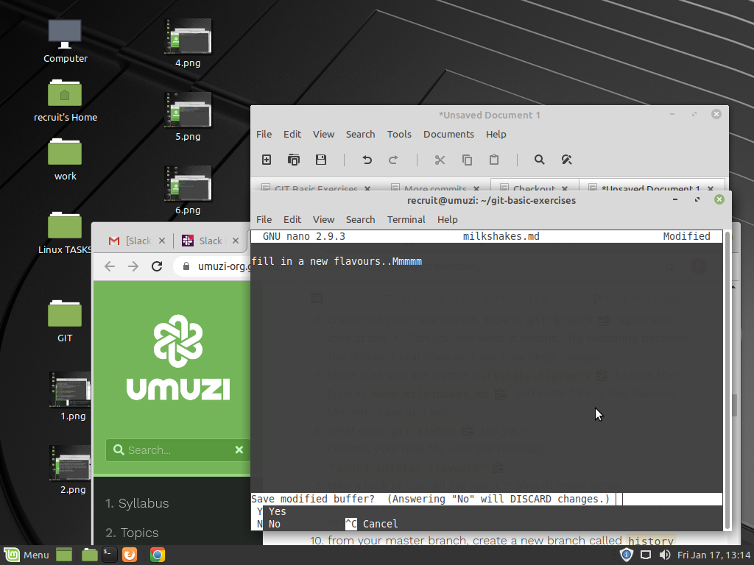

6 recruit@umuzi:~/git-basic-exercises$ git status
On branch milkshake-flavours
Untracked files:
(use "git add <file>..." to include in what will be committed)

...
milkshakes.md

nothing added to commit but untracked files present (use "git add" to track)

=it indicates that a file named milkshakes.md has been created but has not been commited yet.

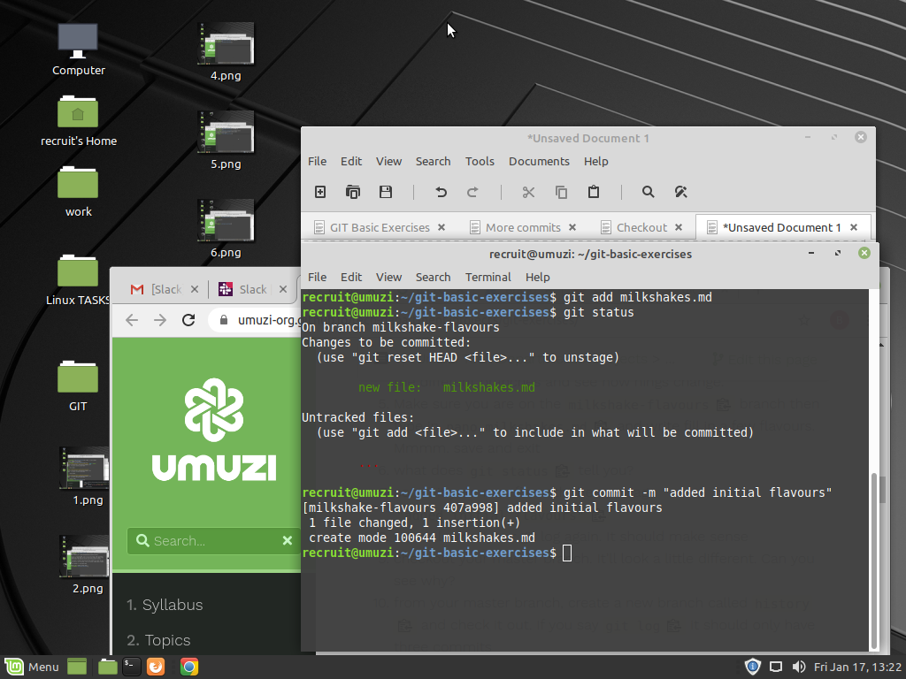
7

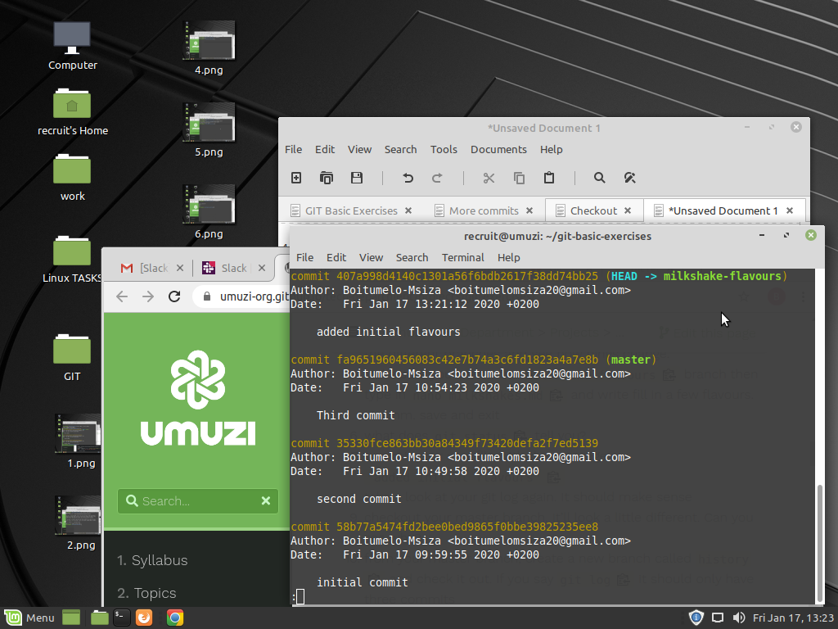
8

9 it does no longer have '*'

10 recruit@umuzi:~/git-basic-exercises$ git checkout master
Switched to branch 'master'
recruit@umuzi:~/git-basic-exercises$ git branch history

12 recruit@umuzi:~/git-basic-exercises$ history > history.txt
= it created a text file under the history branch

14 recruit@umuzi:~/git-basic-exercises$ nano README.md
recruit@umuzi:~/git-basic-exercises$ git add README.md
recruit@umuzi:~/git-basic-exercises$ git commit -m "random readme changes"
[milkshake-flavours 8fa3609] random readme changes
1 file changed, 1 insertion(+), 1 deletion(-)

15 recruit@umuzi:~/git-basic-exercises$ git checkout history
Switched to branch 'history'
recruit@umuzi:~/git-basic-exercises$ cat README.md

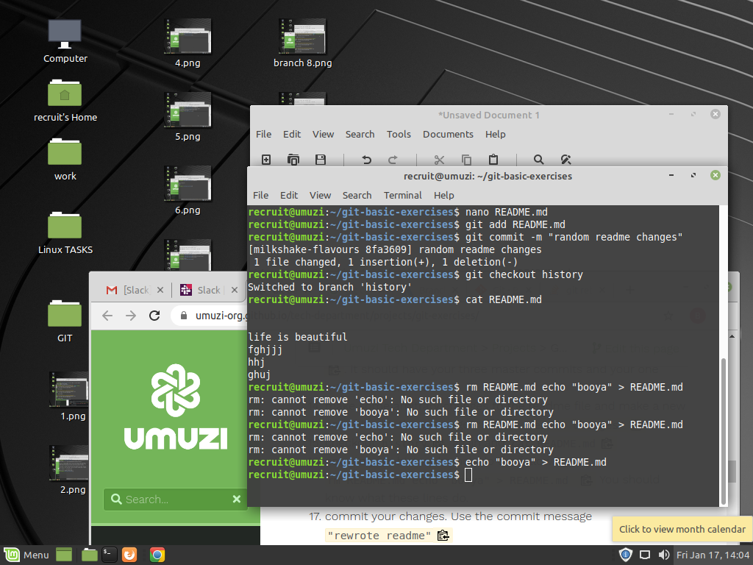
16.

17 recruit@umuzi:~/git-basic-exercises$ git commit -m "Rewrote readme"
[history c2dc4e4] Rewrote readme
1 file changed, 1 insertion(+), 6 deletions(-)

Merging

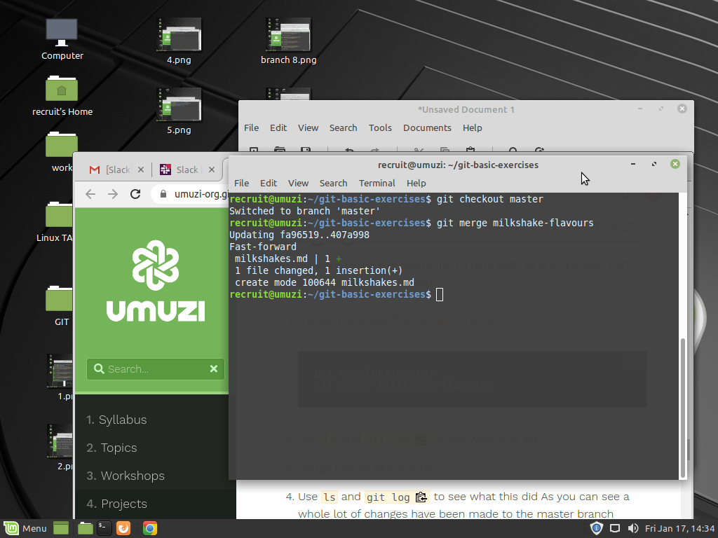
1

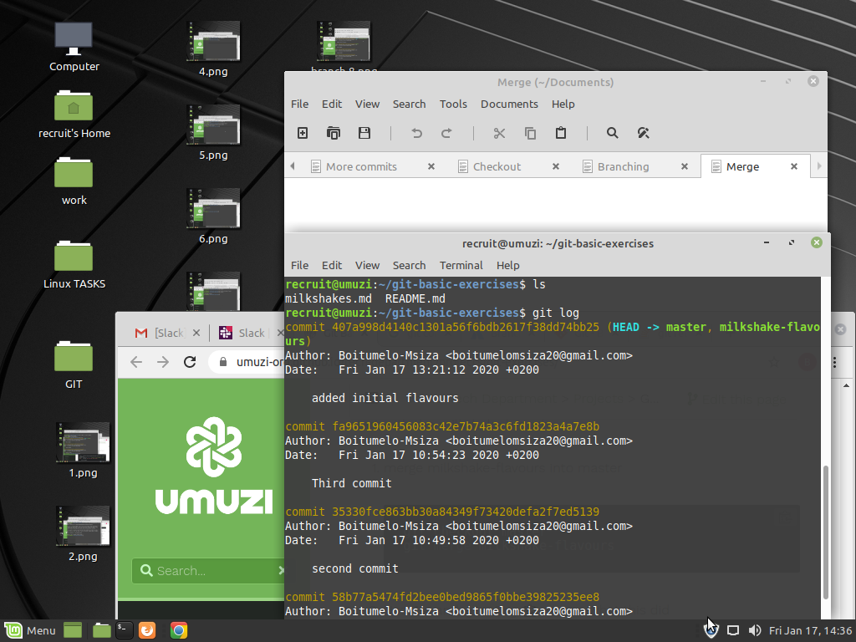
2

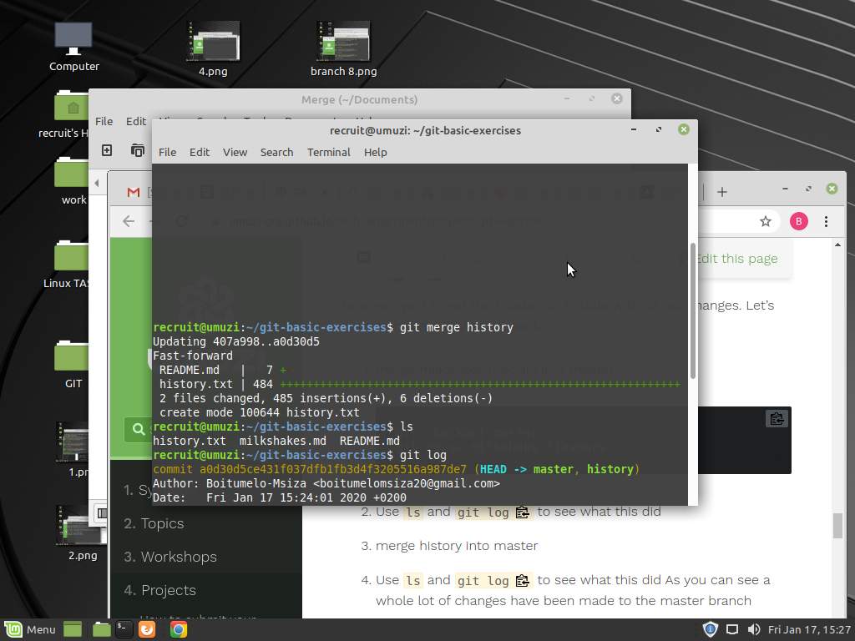
3

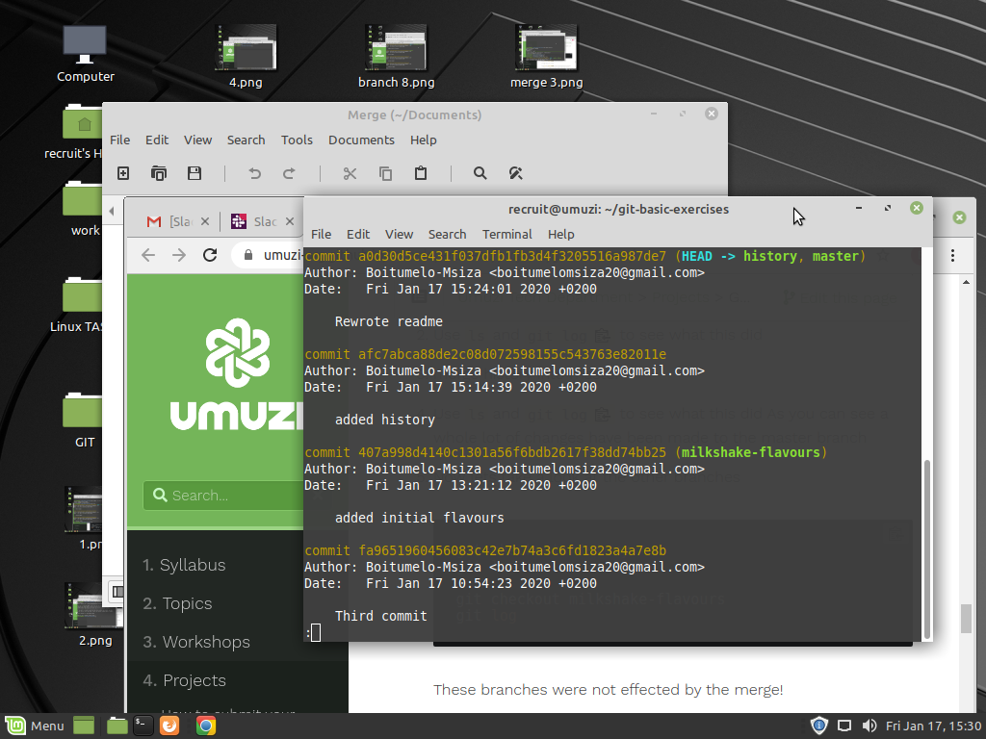
4

Gig Hub

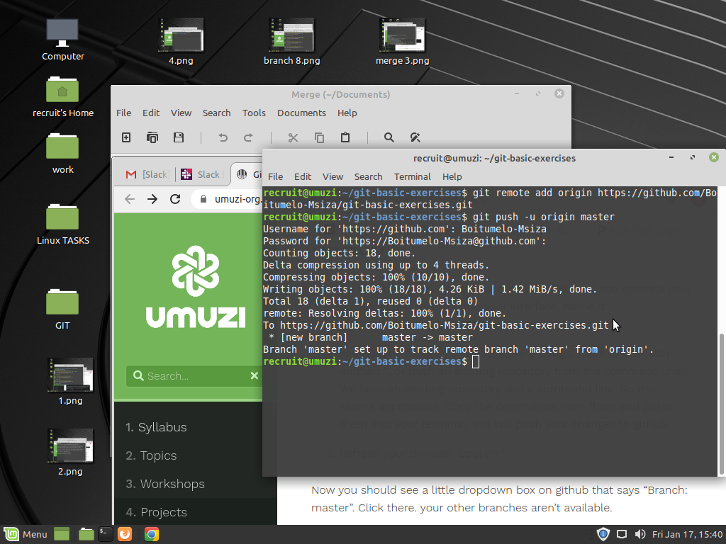
2

4,5,6,7
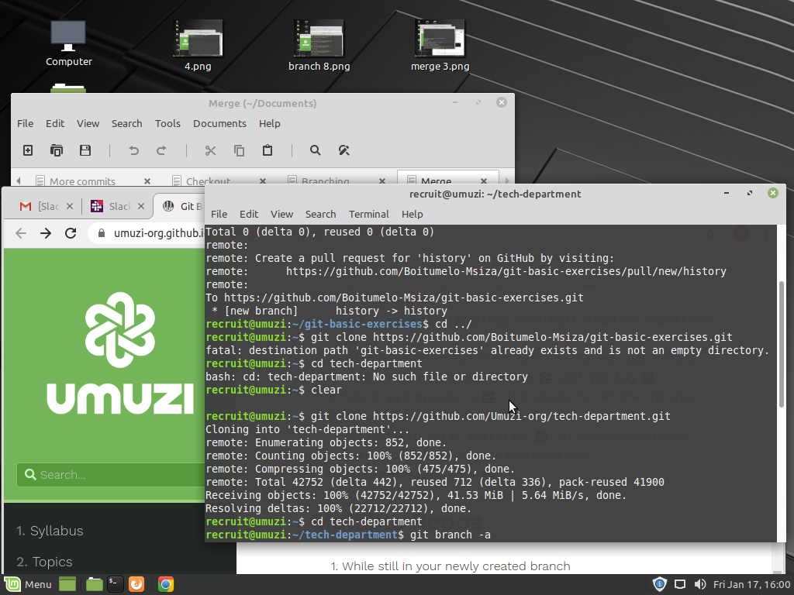
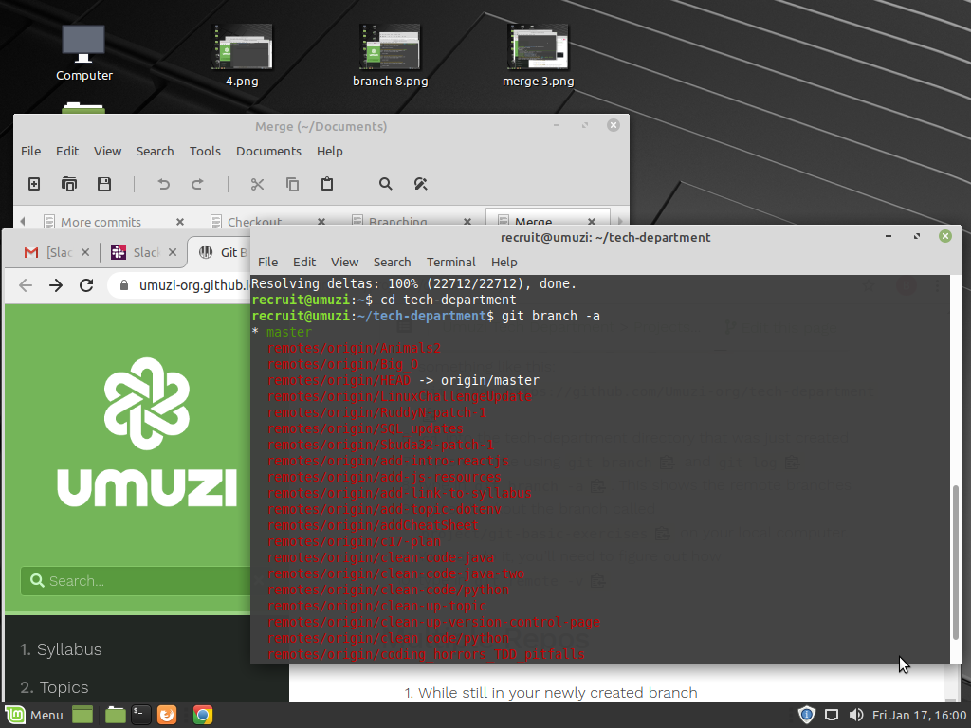
8

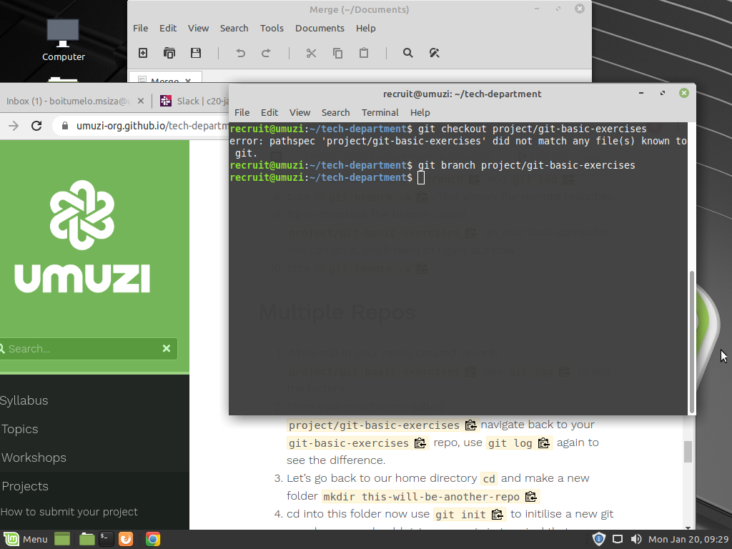
9

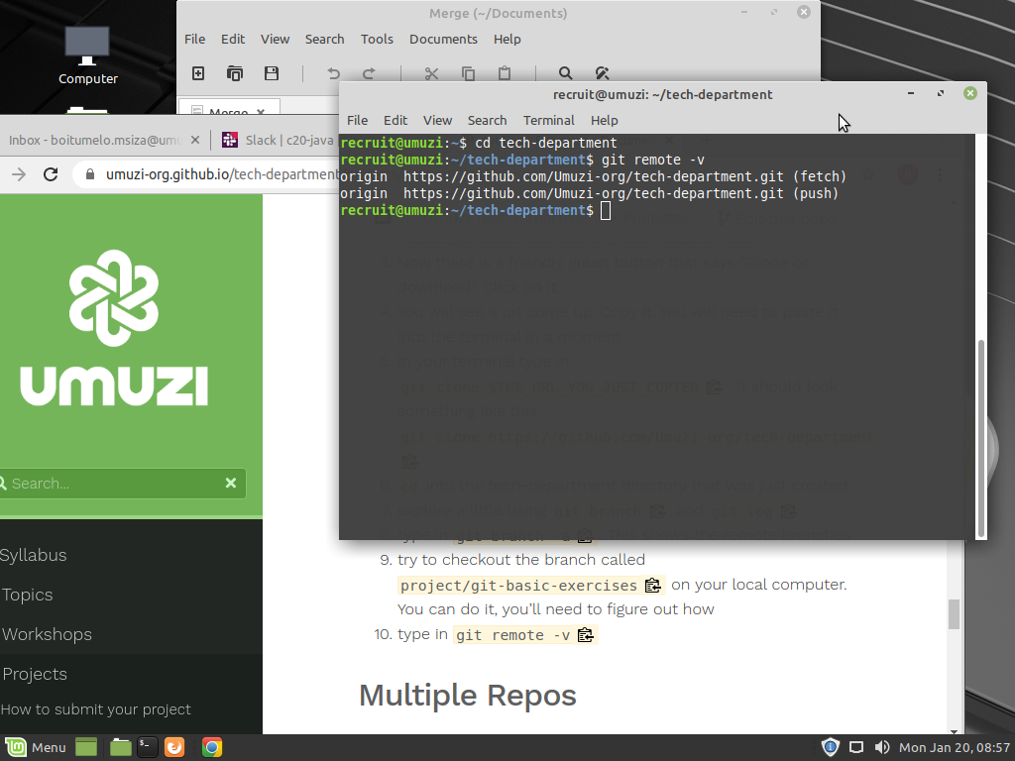
10

Multiple Repos

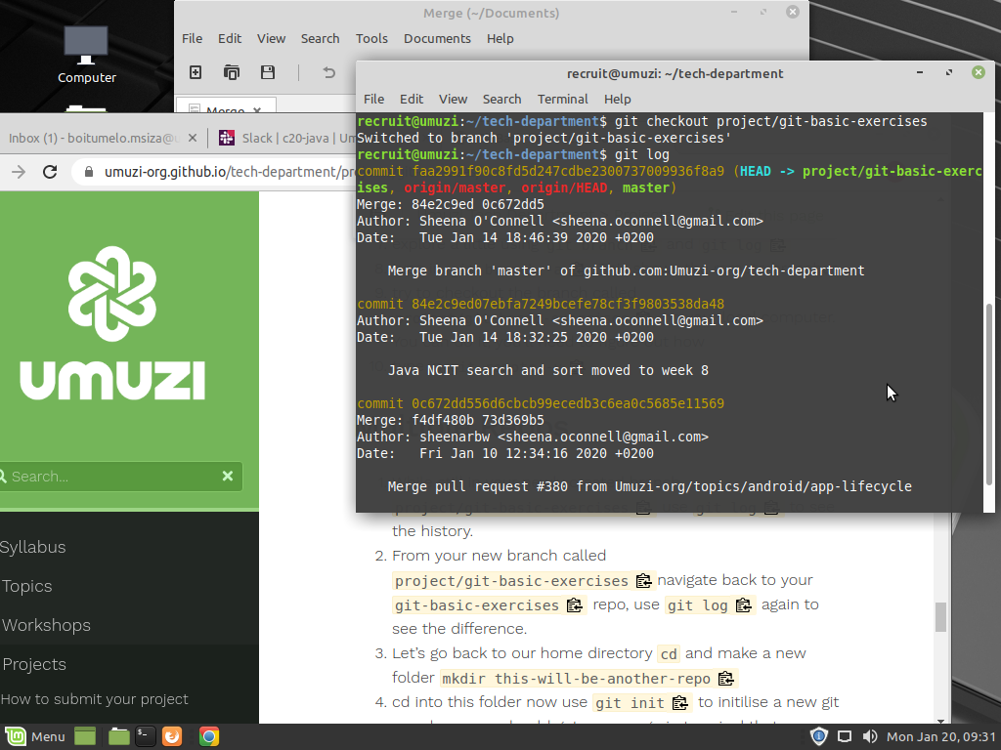
1

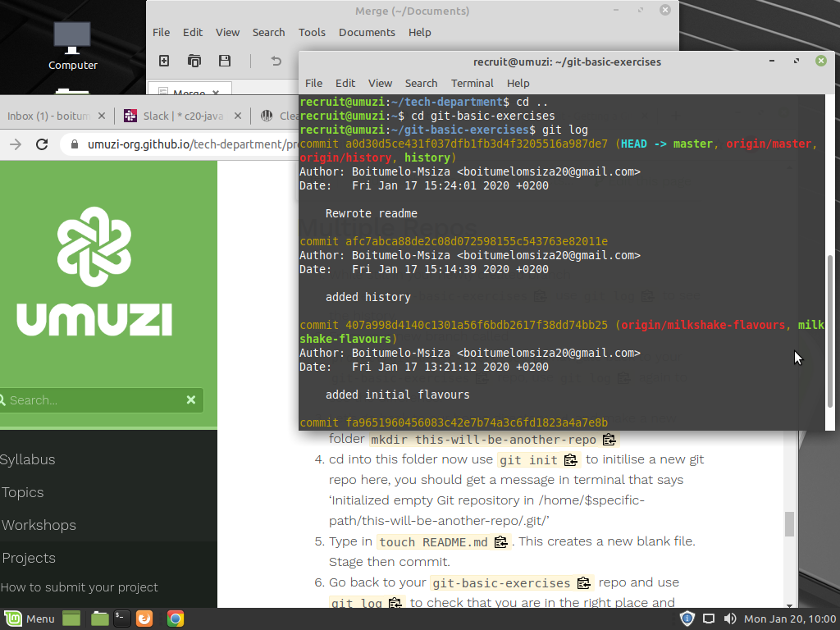
2

3 recruit@umuzi:~/git-basic-exercises$ mkdir this-will-be-another-repo

4 recruit@umuzi:~/git-basic-exercises$ git init

5 recruit@umuzi:~/git-basic-exercises$ touch README.md

GITIGNORE

1 recruit@umuzi:~/git-basic-exercises$ touch ignore-me.db

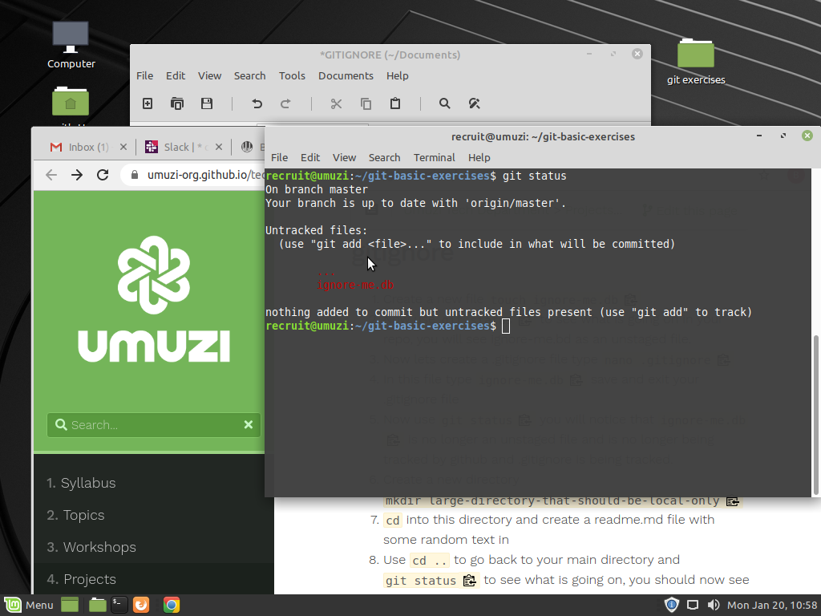
2

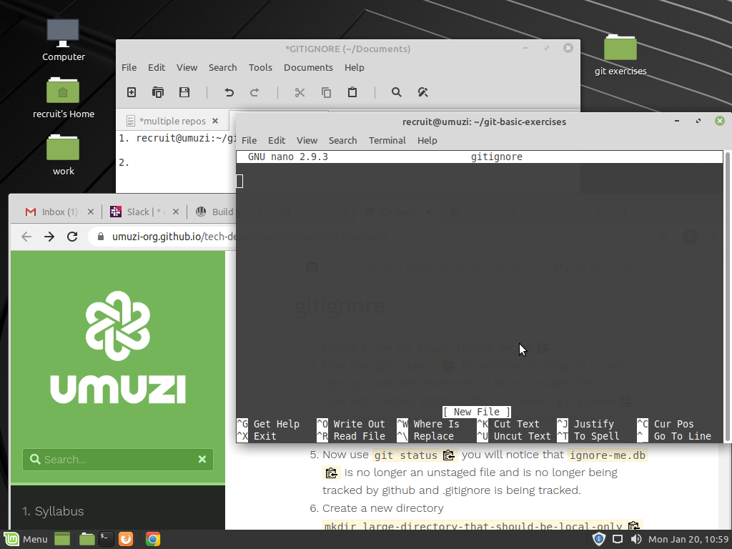
3

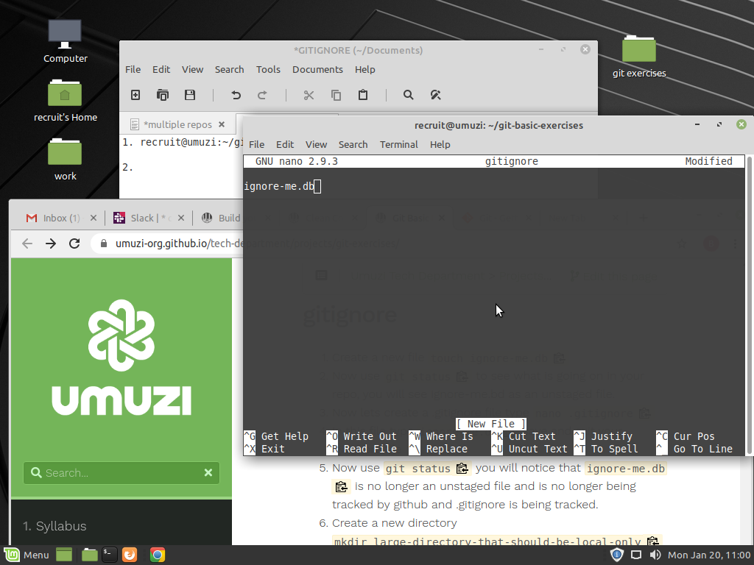
4

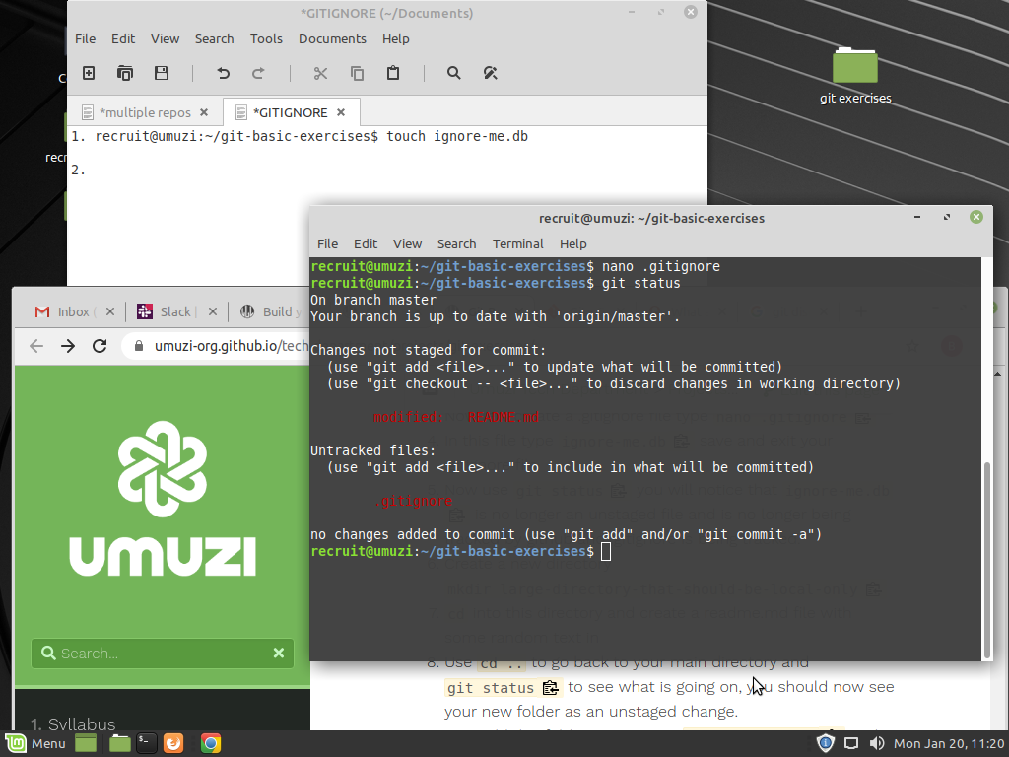
5

6 recruit@umuzi:~/git-basic-exercises$ mkdir large-directory-that-should-be-local-only

7 recruit@umuzi:~/git-basic-exercises$ cd large-directory-that-should-be-local-only
recruit@umuzi:~/git-basic-exercises/large-directory-that-should-be-local-only$ touch readme.md

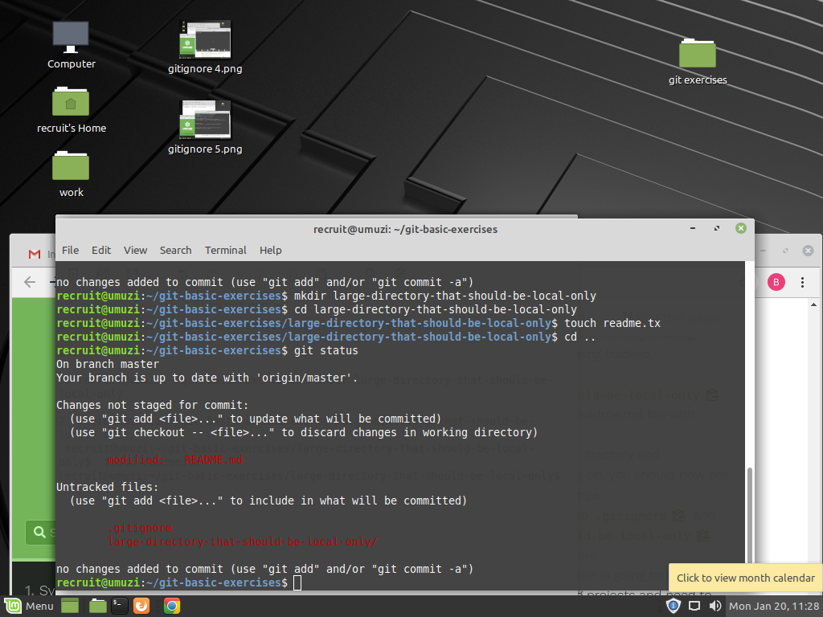
8
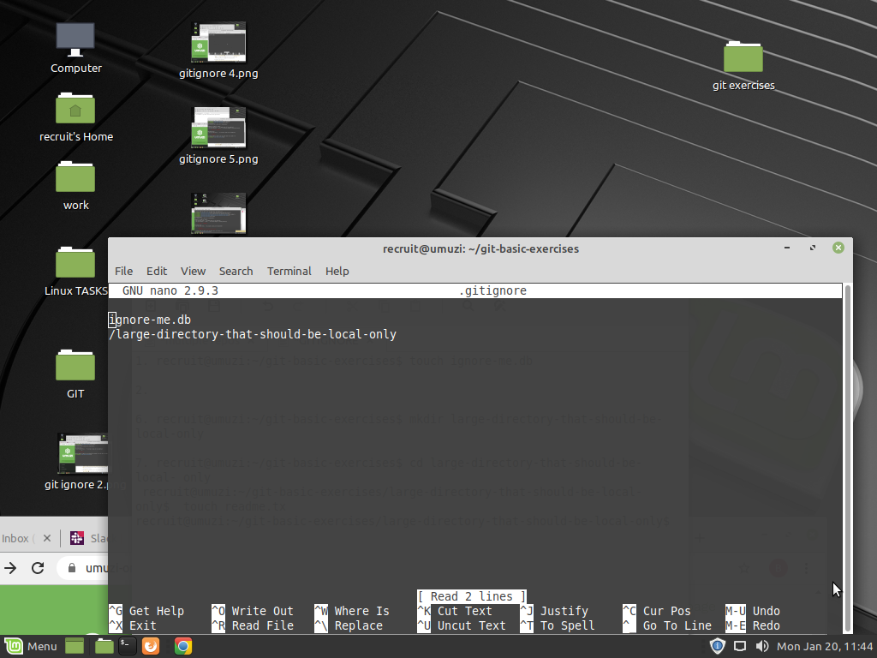
9

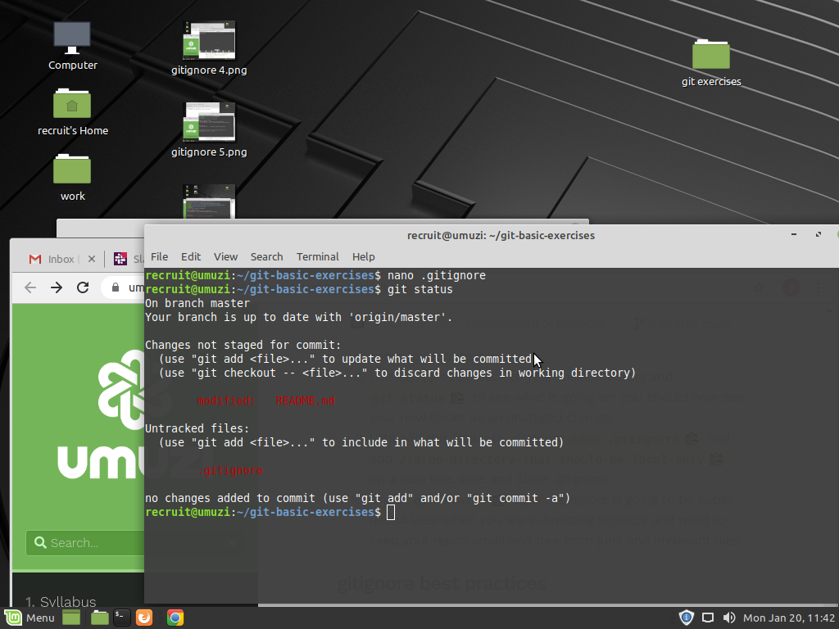
10

